MEDIA KIT

Clippard State Feedback Pinch Valve
Real-Time Valve Verification for Smarter, Safer Automation

Contact Information & Assets p. 2
Press Release p. 3
Social Media Toolkit p. 4
Example Social Media Posts p. 5

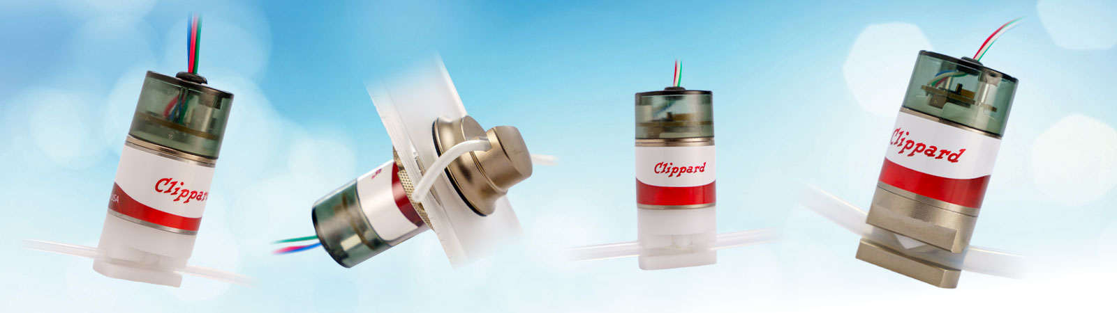
CONTACT INFORMATION

Rachel Desenberg
513.521.4261 x1243
rachel.desenberg@clippard.com

ASSETS

- Product Landing Page
- Technical Data Sheet
- Product Overview Video (YouTube)
- Product Overview Video (.MP4)
- Product Images
- Product Video B-Roll (.MOV)
- Clippard Press Room

PRESS RELEASE

Clippard Introduces New State Feedback Pinch Valve
Real-Time Valve Verification for Smarter, Safer Automation

CINCINNATI, OH—November 3, 2025—Clippard, a leading manufacturer of miniature precision pressure and flow control solutions, announces the release of its new State Feedback Pinch Valve, providing precise, real-time valve status information for enhanced automation, improved diagnostics, and smarter process control. This plug-and-play design verifies valve position both electronically and visually, providing a direct feedback signal that mirrors valve operation and turning a standard pinch valve into a data-ready control component.
Using a built-in sensor, the state feedback circuit detects exactly when the valve plunger moves and outputs a 0 or 12/24 VDC signal to the user’s control or data acquisition system. For normally-closed valves, the output is 0 when the valve is off and 12/24 V when open; for normally-open valves the logic is reversed. LED indicators provide clear, color-coded visual diagnostics: green for power, blue for trigger, yellow for feedback, and red for warnings such as overcurrent, overtemperature, or short circuit. This provides immediate confirmation of valve activity—no external sensors or flow meters required.
The State Feedback Pinch Valve helps verify valve performance, detect faults instantly, and meet traceability or regulatory requirements. With <50 ms response time, it delivers fast, reliable verification of every cycle. It operates on 12 or 24 VDC and accepts 3.3-24 VDC trigger inputs, simplifying integration with PLCs and automation systems.
Key features include:
- Real-time status monitoring via output signal and visual LED feedback
- Closed-loop capability for intelligent, precise control
- Color-coded LED indicators for quick, easy troubleshooting
- Integrated hit and hold circuit for efficient, cool-running operation
- Compact, plug-and-play integration with existing systems
Ideal for smart automation, medical and analytical instrumentation, process control systems, and high-cycle OEM applications, Clippard’s State Feedback Pinch Valve delivers intelligent, reliable valve monitoring in a compact, efficient package.
For more information about the State Feedback Pinch Valve, visit https://www.clippard.com/link/cilmktg15920320 or call 1.877.245.6247.

ABOUT CLIPPARD
Clippard is a third-generation, family-owned manufacturer specializing in precision pressure control, high-resolution flow control, and ultra-low leak solutions. Serving analytical instrumentation, medical device, and miniature process equipment markets, Clippard is trusted worldwide for accuracy, reliability, and performance. From innovative Spider Technology valves to advanced electronic controls and custom-engineered assemblies, Clippard partners with OEMs and design engineers to develop solutions that overcome complex challenges, optimize system performance, and support critical applications.

For more information, please visit clippard.com or call 1.877.245.6247.

# # #
Clippard • 7390 Colerain Avenue, Cincinnati, OH 4539 • 1.877.245.6247
SOCIAL MEDIA TOOLKIT

Clippard State Feedback Pinch Valve

Product Overview

Clippard’s new State Feedback Pinch Valve provides precise, real-time valve status information for enhanced automation, improved diagnostics, and smarter process control. This plug-and-play design turns a standard pinch valve into a verified, data-ready control component.

Key Features
- Real-time status monitoring via output signal
- Color-coded LEDs for power, trigger, feedback, and warnings
- Closed-loop capability for precise process control
- Integrated hit and hold circuit for efficient, cool-running operation
- Operated on 12 or 24 VDC; accepts 3.3-24 VDC trigger signals

Applications
- Smart automation and process control systems
- Medical and analytical instrumentation
- High-cycle OEM systems requiring real-time valve verification
- Data logging for regulatory validation and compliance

Suggested Hashtags

#Clippard #PrecisionControl #FlowControl #SmartControl #ClosedLoop #StateFeedback #MediaIsolation

Social Media Accounts

LinkedIn: @clippard
X (Twitter): @cilcom
YouTube: @clippardinstrumentlaboratory
Facebook: @clippardinstrumentlaboratory

EXAMPLE SOCIAL MEDIA POSTS

Verify. Don’t guess. Clippard’s State Feedback Pinch Valve delivers the real-time status of your pinch valve for enhanced safety and intelligent control.

- Real-Time Status: Electrical signal mirrors valve operation
- Colored LEDs: Power, trigger, feedback, and warning indicators
- Closed-Loop Ready: Enables intelligent, precise control
- Plug-and-Play: Integrates easily with 12 or 24 VDC systems

Ready to learn more?
https://www.clippard.com/link/cilmktg15920320

Looking for a smart isolation valve with real-time feedback? Clippard’s State Feedback Pinch Valve is a plug-and-play solution that accepts 3.3-24 VDC trigger signals for easy integration.
https://www.clippard.com/link/cilmktg15920320

For regulated environments, Clippard’s State Feedback Pinch Valve delivers the traceability, safety, and real-time verification you need—without external sensors.

- Cycle Data: Record every valve shift for validation and compliance logs
- Fast Response: <50 ms response time ensures accurate, repeatable data capture
- Built-In Diagnostics: Color-coded LEDs detect and display faults instantly
- No Extras Needed: Eliminates costly flow meters or position sensors

Ready to learn more? https://www.clippard.com/link/cilmktg15920320

Clippard’s State Feedback Pinch Valve delivers fast, verified operation with <50 ms response time, giving you real-time valve status and tighter process control in every cycle.
https://www.clippard.com/link/cilmktg15920320

If your system needs valve verification, this is for you! Clippard’s State Feedback Pinch Valve transforms a standard pinch valve into a verified, data-ready control component for:

- Smart automation and process control
- Medical & analytical instrumentation
- High-cycle OEM applications
- Systems under FDA, ISO, or data-logging compliance

Ready to learn more? https://www.clippard.com/link/cilmktg15920320

Clippard’s State Feedback Pinch Valve is built for reliability. Its integrated hit & hold circuit reduces heat and power consumption, while color-coded LEDs provide instant visual diagnostics.
https://www.clippard.com/link/cilmktg15920320

